
Year 9 Mathematics Test
End of Term Test- Term 1
Resource Free Section (No calculators, no notes)

Time: 10 mins Name: __________________________________________ /10 marks

Multiple Choice Section: Please circle the correct answer (only circle one)

- Which of the following is equal to the expression a × 7 × 8 × b × a ?
A) 56ab²
B) 56a²b
C) 63ab²
D) 63a²b

- Evaluate 5² × 12⁰
A) 0
B) 10
C) 25
D) 120

- Simplify 3e + 4c × 5d
A) 3e + 9cd
B) 3e + 20cd
C) 23cde
D) 35cde

- Expand -4 (y – 6)
A) 4y – 10
B) 4y – 24
C) -4y – 10
D) -4y + 24

- The formula for the surface area of cylinder is
A) πr²h + 2πr
r: radius
h: height
B) 2πr² + πrh
C) 2πr²h + 2πr
D) 2πr² + 2πrh
Matching Section: Draw a line to match the boxes on the left to the its corresponding box on the right

- Match the graph with its linear equation

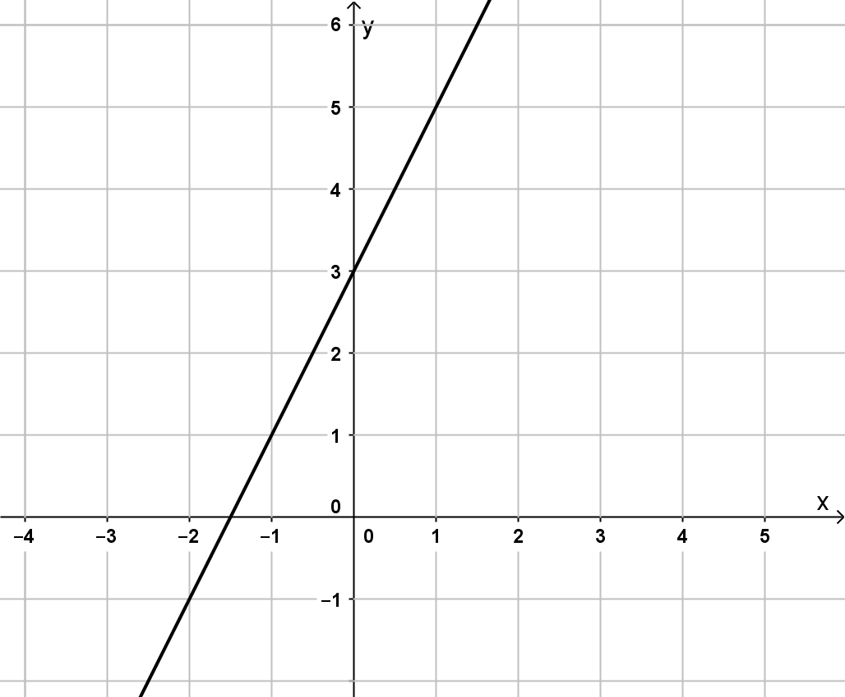 |  | $$y=5x-2$$
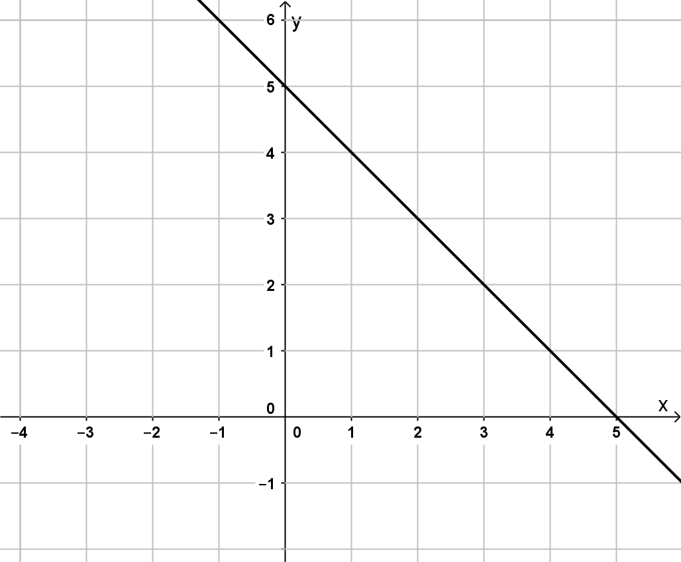 |  | $$y=2x+3$$
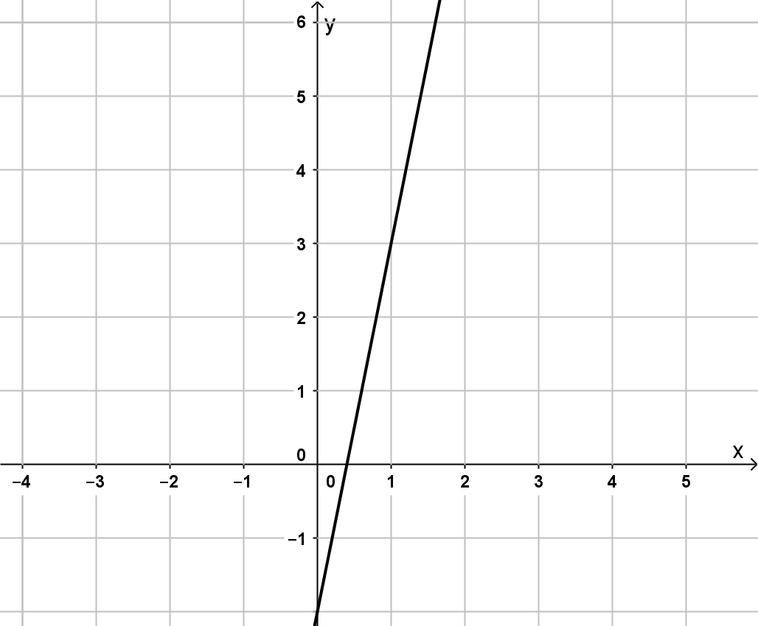 |  | $$x=-1$$
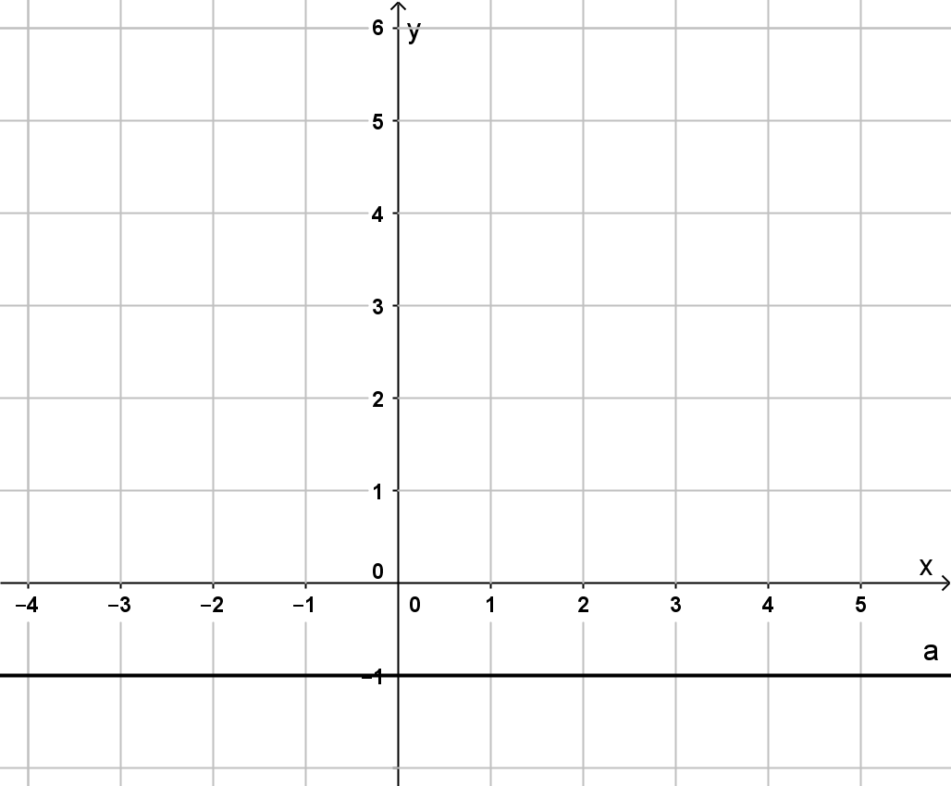 |  | $$y=5-x$$
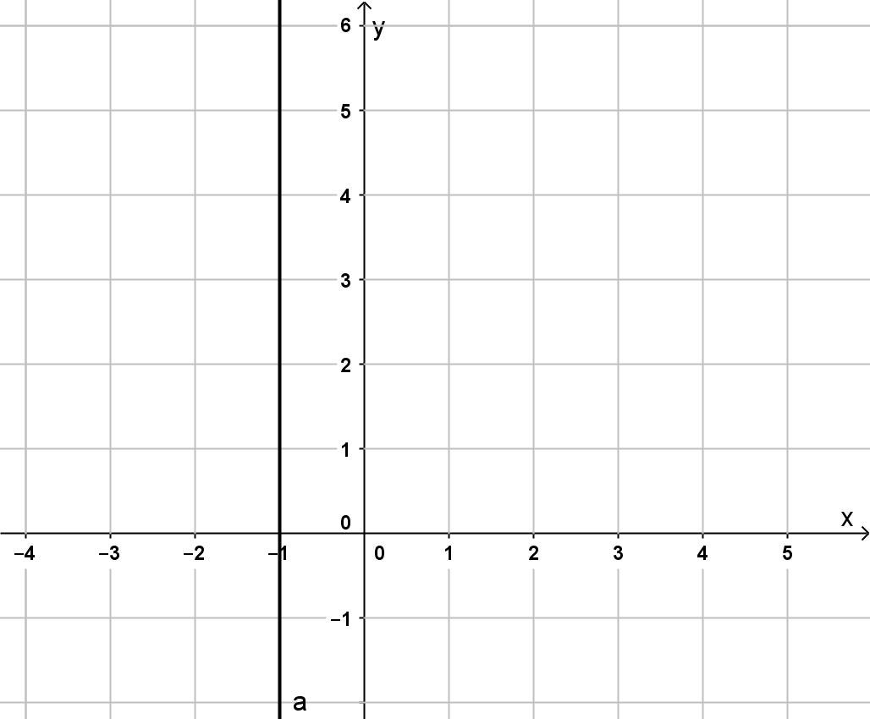 |  | $$y=-1$$


Year 9 Mathematics Test
End of Term Test- Term 1
Resource Section (Calculators and notes allowed)

Time: 40 mins Name: __________________________________________ /40 marks

- Use the index laws to simplify the following; [8 marks]

- 12⁵ ÷ 12³ b) 10⁶ × 10⁰

c) 4h⁻² × 3h⁵ d) (g³)⁷

e) $\frac{21a^{5}}{56a^{2}}$ f) $\frac{w^{8}× w^{-9}}{w^{3}p}$

- Express the following with positive indices; [2 marks]
a) 5⁻³ b) $\frac{2}{e^{-5}}$

- Simplify the following expressions; [2 marks]

- 7 + 4x – 9x b) 4k² × 7k³

- Expand and simplify (where needed) the following expressions; [4 marks]

- 7 ( t – 8 ) b) -6m ( 4m + 5 )

c) -p (2p + 1) + 3p²

- Fully factorise the following expressions; [4 marks]

- 4x + 16 b) 15a – 3ab

c) -24j³ – 18j²

- Calculate the area of the following shapes; [4 marks]

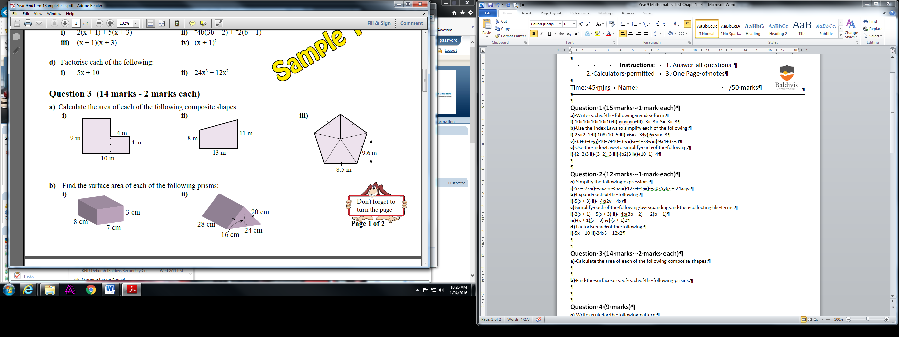

- b)

- Calculate the total surface area of the following shapes; [6 marks]

- A box with a width of 30cm, a length of 40cm and a height of 1.2m

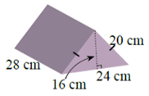

- Consider the following pattern of matchstick arrangements. [4 marks]
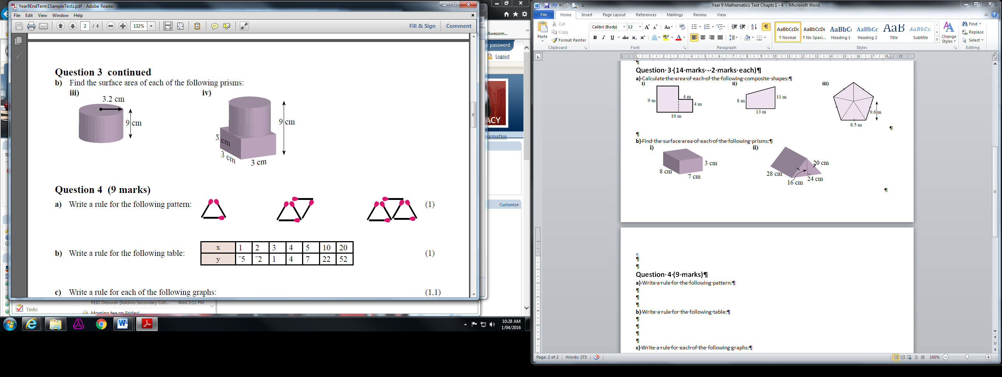
- Is this pattern linear? Why/Why not?

- Fill in the table for the pattern if s is the shape number and m is the number of matches used.

s | 1 | 2 | 3 | 4 | 5
m | 3

- Write a rule for the pattern above to connect the shape number to the number of matches used and use this rule to work out how many matches will be used for the 10th shape

- For the graph to the right; [2 marks]
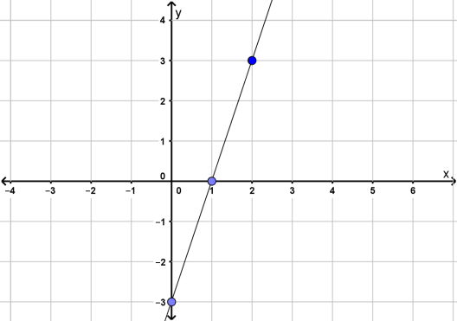
- State the gradient

- Use this gradient, along with the y-intercept,
to create a linear equation for this graph in
the form y= mx +c

- Sketch the following graphs on the grid below; [4 marks]
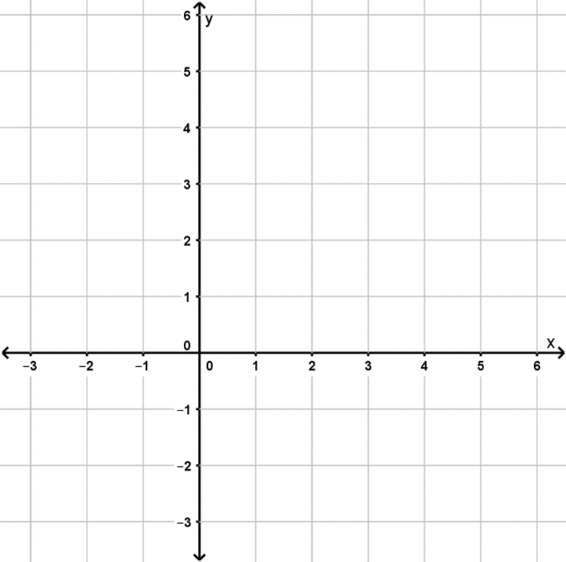
- $y=2x-1$
- $y=-3x+4$

Extension Question

- Morgan is using a Pringles container (see picture) for a project but wants to cover it in coloured paper so it looks like a tower. Morgan thinks it’d be a good idea to turn it upside down so that way the lid isn’t needed.

- If the tub is 7cm across and 23 cm high, what is the total area that needs to be covered?
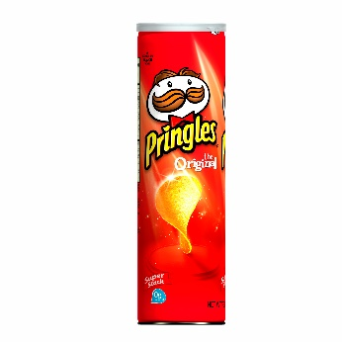
[4 marks]

- For the project, the tub is placed on a cube and Morgan thinks the cube should be the same colour. If the cube has a width of 10cm, what additional area needs to be covered?
(Hint: the bottom of the cube doesn’t need to be covered and only some of the top needs to be covered)
[5 marks]

- Morgan works out the area of the sheets of coloured paper that will be used and thinks that all that needs to be done is to find the total surface area that needs to be covered and divide it by the area of the sheets to work out how many sheets will be needed. Explain why Morgan will actually need more paper than this.
[1 mark]

End of Paper.

